Sponsoren bridgeclub Gieten 2025

INCLUDEPICTURE "../../jvanh/OneDrive/Klussen/Bridge/Bridge%20Bulletin/PHOTO-2024-08-16-11-20-33.jpg" \* MERGEFORMAT INCLUDEPICTURE "../../jvanh/OneDrive/Klussen/Bridge/Bridge%20Bulletin/PHOTO-2024-08-16-11-20-33.jpg" \* MERGEFORMAT INCLUDEPICTURE "../../jvanh/OneDrive/Klussen/Bridge/Bridge%20Bulletin/PHOTO-2024-08-16-11-20-33.jpg" \* MERGEFORMAT INCLUDEPICTURE "../../jvanh/OneDrive/Klussen/Bridge/Bridge%20Bulletin/PHOTO-2024-08-16-11-20-33.jpg" \* MERGEFORMAT INCLUDEPICTURE "../../jvanh/OneDrive/Klussen/Bridge/Bridge%20Bulletin/PHOTO-2024-08-16-11-20-33.jpg" \* MERGEFORMAT INCLUDEPICTURE "../../jvanh/OneDrive/Klussen/Bridge/Bridge%20Bulletin/PHOTO-2024-08-16-11-20-33.jpg" \* MERGEFORMAT INCLUDEPICTURE "../../jvanh/OneDrive/Klussen/Bridge/Bridge%20Bulletin/PHOTO-2024-08-16-11-20-33.jpg" \* MERGEFORMAT INCLUDEPICTURE "../../jvanh/OneDrive/Klussen/Bridge/Bridge%20Bulletin/PHOTO-2024-08-16-11-20-33.jpg" \* MERGEFORMAT INCLUDEPICTURE "../../jvanh/OneDrive/Klussen/Bridge/Bridge%20Bulletin/PHOTO-2024-08-16-11-20-33.jpg" \* MERGEFORMAT INCLUDEPICTURE "../../jvanh/OneDrive/Klussen/Bridge/Bridge%20Bulletin/PHOTO-2024-08-16-11-20-33.jpg" \* MERGEFORMAT INCLUDEPICTURE "../../jvanh/OneDrive/Klussen/Bridge/Bridge%20Bulletin/PHOTO-2024-08-16-11-20-33.jpg" \* MERGEFORMAT INCLUDEPICTURE "../../jvanh/OneDrive/Klussen/Bridge/Bridge%20Bulletin/PHOTO-2024-08-16-11-20-33.jpg" \* MERGEFORMAT INCLUDEPICTURE "../../jvanh/OneDrive/Klussen/Bridge/Bridge%20Bulletin/PHOTO-2024-08-16-11-20-33.jpg" \* MERGEFORMAT INCLUDEPICTURE "../../jvanh/OneDrive/Klussen/Bridge/Bridge%20Bulletin/PHOTO-2024-08-16-11-20-33.jpg" \* MERGEFORMAT INCLUDEPICTURE "../../jvanh/OneDrive/Klussen/Bridge/Bridge%20Bulletin/PHOTO-2024-08-16-11-20-33.jpg" \* MERGEFORMAT INCLUDEPICTURE "../../jvanh/OneDrive/Klussen/Bridge/Bridge%20Bulletin/PHOTO-2024-08-16-11-20-33.jpg" \* MERGEFORMAT INCLUDEPICTURE "../../jvanh/OneDrive/Klussen/Bridge/Bridge%20Bulletin/PHOTO-2024-08-16-11-20-33.jpg" \* MERGEFORMAT INCLUDEPICTURE "../../jvanh/OneDrive/Klussen/Bridge/Bridge%20Bulletin/PHOTO-2024-08-16-11-20-33.jpg" \* MERGEFORMAT INCLUDEPICTURE "../../jvanh/OneDrive/Klussen/Bridge/Bridge%20Bulletin/PHOTO-2024-08-16-11-20-33.jpg" \* MERGEFORMAT 

Seizoen 2009/2010









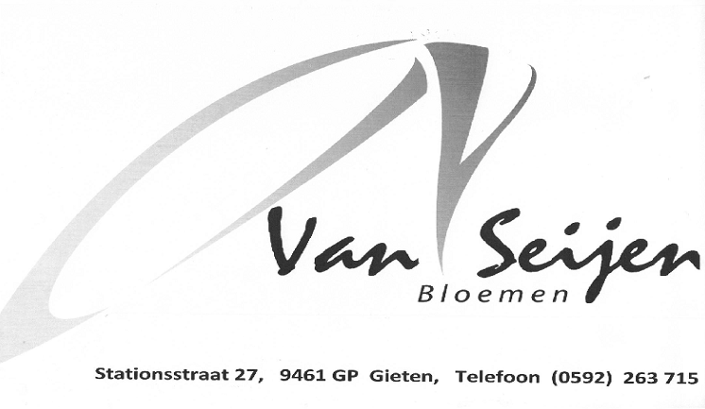












Openingstijden donderdag t/m zaterdag 9.00 uur - 17.00 uur.
Overige dagen op afspraak. Telefoon: 0592-744076.




Zuiderblokken 1, Drouwenermond
www.degulleboergondier.nl

